PRIM’S ALGORITHM-EXAMPLE

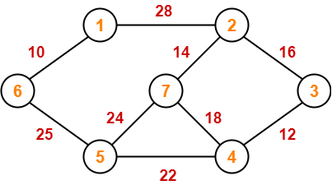
- mstset = { }
- Key values = {0, INF, INF, INF, INF, INF, INF}
- Pick the vertex with minimum key value(Vertex 1)
- Include the vertex 1 to mstset
- mstset = {1}
- Update the key values of adjacent vertices of vertex 1
- Adjacent vertices are 1 & 6
- key values={0,28,INF,INF,INF,10,INF}
- Pick the vertex 6(Minimum key value)
- Now add 6 to mstset ,mstset={1,6}
- Update the key values of adjacent vertices of vertex 6 which are not yet included( Vertex 5 only)
- key values={0,28,INF,INF,25,10,INF}
- Pick the vertex 5(Minimum key value)
- Now add 5 to mstset ,mstset={1,6,5}
- Update the key values of adjacent vertices of vertex 5 which are not yet included( Vertices 4 & 7)
- key values={0,28,INF,22,25,10,24}
- Pick the vertex 4(Minimum key value)
- Now add 4 to mstset ,mstset={1,6,5,4}
- Update the key values of adjacent vertices of vertex 4 which are not yet included( Vertices 7 & 3)
- key values={0,28,12,22,25,10,18}
- Pick the vertex 3(Minimum key value)
- Now add 3 to mstset ,mstset={1,6,5,4,3}
- Update the key values of adjacent vertices of vertex 4 which are not yet included( Vertex 2 only)
- key values={0,16,12,22,25,10,18}
- Pick the vertex 2(Minimum key value)
- Now add 2 to mstset ,mstset={1,6,5,4,3,2}
- Update the key values of adjacent vertices of vertex 2 which are not yet included( Vertex 7 only)
- key values={0,16,12,22,25,10,14}
- Pick the vertex 7(Minimum key value)
- Now add 7 to mstset ,mstset={1,6,5,4,3,2,7}
- We can stop the construction of MST as mstset contains all the vertices.

16
2

0
1

7

14
12
6

5

3

4

10
22
25
Fig: MST constructed using the Prim’s Algorithm
Key values are specified along with the vertices
Total cost of the MST=99 (Obtained by adding the key values)

